GOVERNMENT DENTAL COLLEGE AND HOSPITAL , KADAPA.

DEPARTMENT OF PERIODONTOLOGY AND IMPLANTOLOGY.



SEMINAR PRESENTATION ON- “ PERIODONTAL LIGAMENT”.

**GUIDED BY: PRESENTED BY:**

**DR.P.SURESH, DR.K.LATHA,**

**PROFESSOR & HOD, 1ST PG STUDENT,**

**DEPT OF PERIODONTICS . DEPT OF PERIODONTICS .**

CONTENTS:

* INTRODUCTION
* DEFINITIONS
* DEVELOPMENT OF PDL
  + DEVELOPMENT OF SHARPEYS FIBERS
  + FIBER GROWTH FROM SHARPEYS FIBER TO CONTINUOUS PDL
  + PRINCIPLE FIBER FORMATION
* SHAPE & SIZE OF PDL
* STRUCTURE OF PDL
  + CELLULAR ELEMENTS
  + EXTRACELLULAR ELEMENTS
* OTHER STRUCTURES IN THE CONNECTIVE TISSUE
* FUNCTIONS OF PDL
* PERIODONTAL LIGAMENT HOMEOSTASIS
* AGE CHANGES IN PDL
* CLINICAL CONSIDERATIONS
* CONCLUSION
* REFERENCES

INTRODUCTION:

* The periodontium, consisting of soft tissues like gingiva, periodontal ligament and hard tissues like cementum and bone, is a hierarchically organized tissue, whose primary role is to provide physical and mechanical support of the teeth.

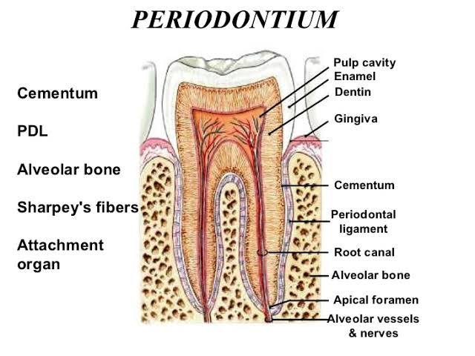

Definitions:

* The periodontal ligament is composed complex vascular & highly cellular connective tissue that surrounds the tooth root & connects it to the inner wall of the alveolar bone.

- CARRANZA

* The connective tissue that surrounds & attaches root of teeth to the alveolar bone.

- GPT

* The periodontal ligament occupies the periodontal space, which is located between the cementum & the periodontal surface of the alveolar bone & extends coronally to the most apical part of the lamina propria of the gingiva.

- ORBAN

* The periodontal ligament is the soft, richly vascular & cellular connective tissue which surrounds the root of the teeth & joins the root cementum with the socket wall.

- LINDHE.

DEVELOPMENT OF PDL:

* The development of periodontal ligament begins with root formation, prior to tooth eruption.
* The continuous proliferation of the internal and external enamel epithelium forms the cervical loop of the tooth bud.
* This sheet of epithelial cells grows apically, in the form of Hertwig’s Epithelial Root Sheath, between dental papilla and dental follicle.
* At this stage, the sheath forms a circumferential structure encompassing dental papilla and separating it externally from dental follicle cells.
* The dental follicle cells present between alveolar bone and epithelial root sheath are composed of two sub-populations,

-Mesenchymal cells of the dental follicle proper

-The perifollicular cells

* The perifollicular cells are widely spaced compared to dental follicle proper and they contain euchromatic nucleus, very little cytoplasm, RER, mitochondria and free ribosomes and inactive golgi area.
* As the root formation continues, the perifollicular cells gain their polarity and cell volume and synthetic increases.
* They become elongated and contain increased amounts of RER, mitochondria and active golgi complex.
* The dental follicle cells forms into fibroblasts, cementoblasts and osteoblasts.
* These cells remodel the follicle to periodontal ligament, which starts at the CEJ and proceeds in an apical direction.
* As a result, they synthesize and deposit collagen fibrils and glycoprotiens in the developing periodontal ligament.
* The developing periodontal ligament and mature periodontal ligament contain undifferentiated stem cells that retain the potential to differentiate into osteoblasts, cementoblasts and fibroblasts.

Formation of Sharpey’s Fibers:

* The formation of sharpey’s fibers is the first step in periodontal ligament development.
* It starts on the tooth side first, along with the formation of cementum on developing root dentin.
* Acellular extrinsic fiber cementum (AEFC) is the predominant tissue that connects the tooth root to the periodontal ligament.
* AEFC is formed after odontoblasts from the dental papilla deposit non-mineralised root dentin.
* AEFC matrix is produced from fibroblast like cells present immediately coronal to HERS, they posses numerous cytoplasmic processes towards non-mineralised dentin matrix and produce initial collagenous matrix, which results in a dense collagenous fiber fringe oriented perpendicular to root surface.
* The fiber fringe is invaided by cementoblasts that originate from dental follicle, they produce additional cementum matrix that is subsequently mineralized.
* Mineralization advances from dentin surface towards periodontal ligament space. It stops before the fiber fringe is completely mineralized, approx 10-20μ of collagenous stump protruding into periodontal ligament space, at these site fibers of early periodontal ligament attaches and forms continuous with root and periodontal ligament.
* The sharpey’s fibers on the bone side form differently, the alveolar bone is already mineralized by the time of root and periodontal ligament starts to develop.
* Alveolar bone undergoes extensive remodelling, it is at these remodelling sites the sharpey’s fibers get attached and embedded into bone.
* Bone bound sharpey’s fibers are formed in several ways.
* Firstly, the areas where osteoblasts form the osteoid. Here, both newly formed and existing fibers can attach directly to osteoid and get entrapped within when calcified.
* Similarly, periodontal ligament fibers can attach to areas of resorption. Also these fibers get entrapped in calcified matrix after osteoblast or chestrate matrix mineralization.
* Finally, the periodontal ligament fibers can attach to bone at areas where fibers from osteoid escape mineralization and protrude into periodontal ligament space.
* Sharpey’s fibers from bone and cementum differ in size and number, it might be the result of their specific method of development.

FIBER GROWTH:

* During sharpey’s fibers formation the central part of the periodontal ligament space is composed of loosely arranged collagenous mass, which contain numerous mesenchymal precursor cells, that may differentiate into periodontal ligament cells.
* The fibroblasts from the PDL cells effectively shape the PDL into its functional configuration by producing new extracellular matrix and remodeling existing structures.
* Matrix remodeling starts almost simultaneously on both sides, beginning at the ends of sharpey’s fibers as collagenous stumps, from which PDL fibers

grows into PDL space without distinguishable central zone.

PRINCIPLE FIBER FORMATION & THEIR ORIENTATION AT DIFFERENT STAGES OF ODONTOGENESIS:

PRE- EMERGENCE STAGE:

* When approx. 1/3rd of the root is formed, developing PDL has loosely arranged collagenous elements.
* Near CEJ, fibers arise from cementum and follow the outline of the crown.
* In middest region, closely spaced fibers are aligned perpendicular to long axis of the root, in this region fibers arising from the bone are occasionally seen.
* 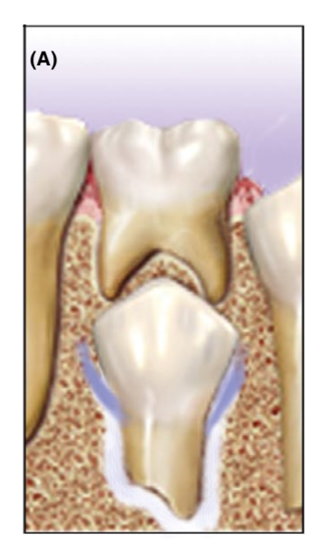In peri-apical region, fibers near the cementum and alveolar bone are densely packed, but loosely arranged in central third region of the periodontal ligament space. These fibers pass, in an occlusal direction, parallel to long axis of the root.

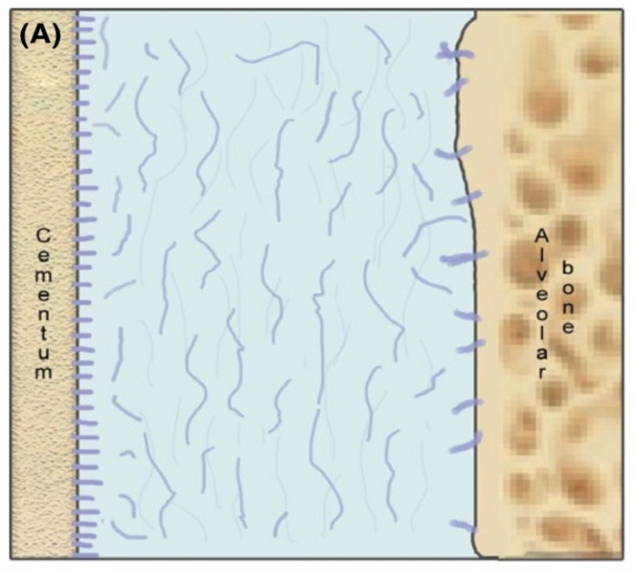

EMERGENCE IN THE ORAL CAVITY (PRE-OCCLUSAL STAGE):

* At this stage, organized fibers are seen in coronal and cervical areas.
* Dentogingival fibers show their mature occlusal orientation and follow the enamel surface from cementum to interproximal gingival.
* When adjacent tooth is not erupted, developing transseptal fibers extend over alveolar crest in an oblique-apical direction towards CEJ of the un-erupted tooth.
* When adjacent tooth is erupted, re-orientation of the transeptal fibers in a superior –oblique direction towards erupted tooth.
* Apically, developing PDL is not well organized.
* From middle third to apex, closely spaced brush like fibers emerge from cementum, at bone they are loosely spaced.
* The fibers are not continuous and are separated by loosely spaced collagenous substance.

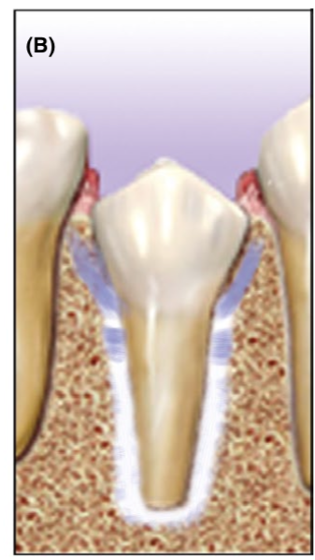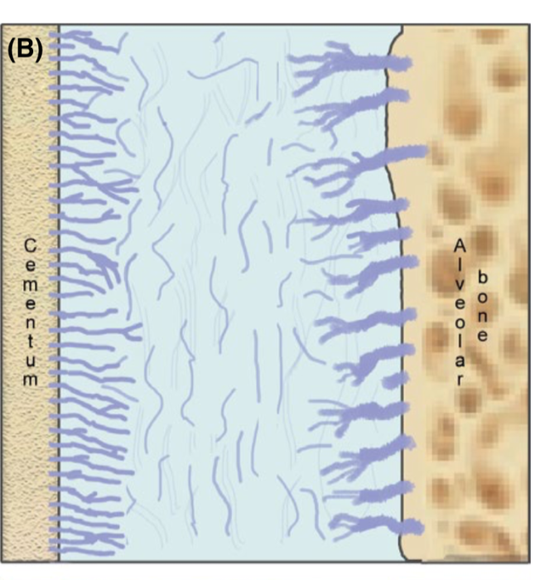

FIRST OCCLUSAL CONTACT:

* At this stage PDL organization is more advanced and dentogingival and transseptal fibers are well arranged.
* Coronal third - horizontal fibers are almost developed,
* Middle third - oblique fibers are still being formed.

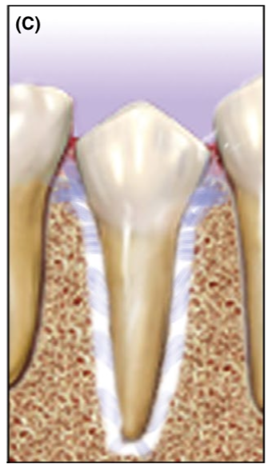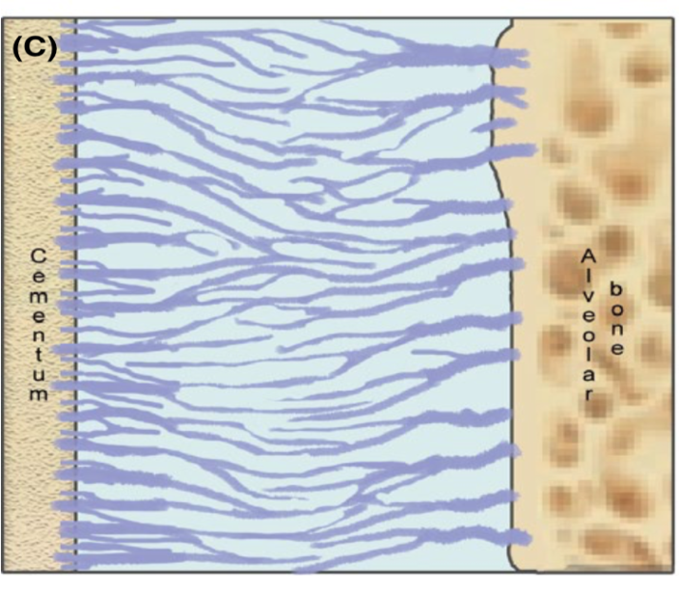

MATURE LIGAMENT ( FULL OCCLUSAL CONTACT):

* There is progressive apical maturation of oblique fiber bundle.
* 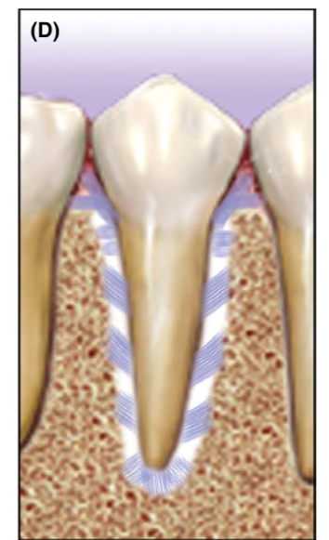As a result of dental loading, overall fiber bundles thicken and form a continuous network that passes from cementum and alveolar bone without a distinguishable central zone.

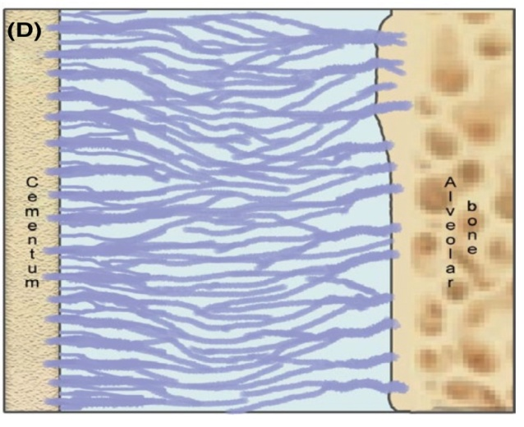

SIZE AND SHAPE OF PDL:

* Width of the PDL ranges from 0.15 – 0.38 mm.
* Its thinnest in middle third of the root, with a hour glass appearance.
* Thickness in young adult – 0.21 mm
* Mature adult – 0.18 mm
* Older adult - 0.15 mm
* PDL appears as the periodontal ligament space on a radiograph is about 0.4 – 1.5 mm
* Periodontal ligament space of permanent teeth is narrower than those of deciduous teeth.
* Thickness at the time of eruption – 0.1 to 0.5 mm
* Function - 0.2 to 0.35 mm
* Hypo-function- 0.1 to 0.15 mm.

STRUCTURE OF PDL :

* Cellular elements:
  + Synthetic cells
  + Resorptive cells
  + Progenitor cells
  + Epithelial cell rests of malassez
  + Defence cells
* Extracellular elements:
  + Fibers
  + Ground substances

SYNTHETIC CELLS:

* Osteoblasts:
  + Bone forming cells, lines tooth socket
  + Cuboidal
  + RER, mitochondria & vesicles are abundant in active cells
  + Desmosomes & tight junctions.

Fibroblasts :

* + Predominant cell type
  + Origin – partly from dental papilla & follicle
  + Fusiform, abundant organelles for protein synthesis & secretion
  + Produce growth factors & cytokines like IGF–1, BMPs, PDGF, IL-1.

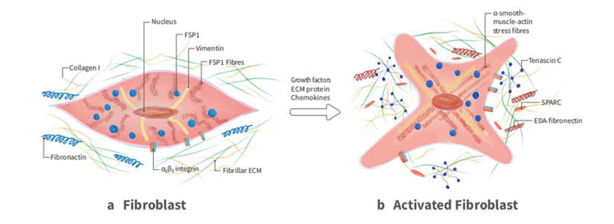

* CEMENTOBLASTS:
  + Line the surface of cementum, irregular arrangement.
  + Almost cuboidal, abundant cytoplasm & organelles.
  + Cells secreting cementum – basophilic cytoplasm.
  + Gap junctions & desmosomes.

RESORPTIVE CELLS:

* Osteoclasts:
  + Cells that resorb the bone
  + Large multinucleated or small mononuclear cells
  + Multinucleated cells are formed by fusion
  + Howship’s lacunae
  + Numerous mitochondria, lysosomes, abundant golgi saccules, free ribosome's, but little RER
  + Ruffled borders
  + Clear zone
* FIBROBLASTS:
  + Phagocytose & show rapid degeneration of collagen, resulting in fast turn over of collagen.
  + Early studies – collagen degradation is by extra-cellularly by collagenase.
  + Later – due presence of cellular organelles

intracellularly

* Acc to some studies, collagen is degraded intra-cellularly in healthy tissues.
* Hence, the degradation is both intra & extracellular.

INTRACELLULAR DEGRADATION:

* In vitro studies, showed fibroblasts have the capability of phagocytosing collagen fibrils from extracellular environment & cause the collagen degradation.
* Cell surface alkaline phosphatase & MMPs may be involved in internalizing collagen fibrils.
* Lysosomal cysteine proteinase of lysosomal granules are capable of rapid degradation of collagen fibrils.

phagocytosis of collagen fibrils by fibroblasts

Banded fibril surrounded by an electron lucent zone

Banded fibrils surrounded by an electron dense zone

Phagosome fuses with primary lysosome to form phagolysome

Indistinct banding, electron dense zone

* Enzymatic degeneration of fibrils, until fibrils loose their characteristic structure

EXTRACELLULAR DEGRADATION:

* Involves collagenases (MMP-1), it is thought to cleave the triple helical portion
* Along with MMP-4, it leads to denaturation of collagen under physiological conditions
* Rest undergo proteolysis by MMP-2 (gelatinase) & MMP-5
* Glycoproteins (fibronectin), proteoglycan on fibril surface, which mask the collagen binding site must be remove by stromelysin (MMP-3), before the action of collagenase.
* CEMENTOCLASTS:
  + They resemble osteoclasts
  + Occasionally seen in normal pdl, as cementum doesn’t undergo remodelling continuously, but is deposited continuously throughout the life.
  + Resorption occurs under certain conditions

PROGENITOR CELLS:

* All connective tissues, including pdl contain progenitor cells.
* It is evident that progenitor cells are present, that show burst of mitosis upon application of pressure in orthodontic therapy & after wounding , which stimulate proliferation & differentiation, forming cells of pdl.
* Adjacent to blood vessels.

EPITHELIAL CELL RESTS OF MALASSEZ:

* They were first described by Malassez in 1884.
* Pdl contains epithelial cells close to cementum.
* They appear as strands, islands or tube-like structures parallel to root surface & about 25μ from cemental surface.
* Distribution varies with age & site. 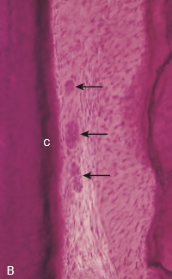

DEFENCE CELLS:

* MAST CELLS:
  + Round or ovoid with D=12 to 15μm, associated with blood vessels.
  + Numerous granules & small, round nucleus.
  + It degranulates in response to antigen-antibody reaction on the surface.
  + They contain heparin, histamine & in some animals seratonin.
  + Histamine plays role in inflammatory conditions.

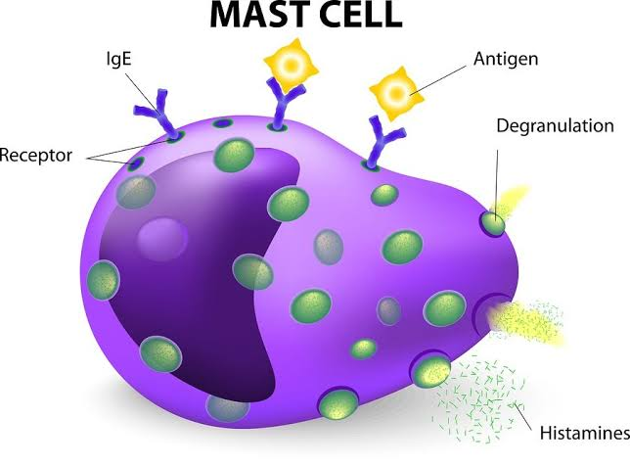

* Occasionally seen in normal pdl.
* Histamine causes, proliferation of endothelial & mesenchymal cells & thus play a role in regulating their populations.
* MACROPHAGES:
  + Present in pdl & located adjacent to blood vessels.
  + Derived from monocytes, & phagocytose particulate matter & micro-organisms.
  + Dual role: 1.phagocytosing dead cells

2.secreting growth factors

* EOSINOPHILS:
  + Occasional
  + Phagocytosis
  + Granules are seen

E**X**TRA-CELLULAR SUBSTANCES:

* GROUND SUBSTANCE
* FIBERS

GROUND SUBSTANCES:

* 70% - water
* Significant effect on the tooth’s ability to withstand stress load.
* Gel – like matrix.
* Functions: ion & water binding & exchange,

control of collagen fibrillogenesis &

fiber orientation &

binding of growth factors.

* Ground substance is secreted by fibroblasts.
* It consists of mainly : glycosaminoglycans

proteoglycans &

glycoproteins.

GLYCOSAMINOGLYCANS:

* Main types are hyaluronan, dermatin, chondroitin & heparin sulphates.
* Hyaluronan – large volume
* Located near the surface of collagen fibrils.

PROTEOGLYCANS:

* These are compounds containing glycosaminoglycans attached to a protein core
* Two main:
* Proteoglycans containing chondroitin sulphate &
* Dermatan sulphate hybrids

GLYCOPROTEIN:

* Predominant type is fibronectin
* it promotes attachment of cells to collagen, also involved in cell migration & orientation.
* Others like tenascin & vitronectin.
* Tenascin – adjacent to alveolar bone & cementum. It acts to transfer the forces of mastication & stresses.
* Vitronectin found adjacent to elastic fibers.

FIBERS:

* Principle fibers are important components of pdl.
* Sharpey’s fibers.
* Connective tissue fibers are mainly collagenous
* Small amounts of oxytalin & reticular fibers.

**COLLAGEN:**

* Collagen is a protein with different amino acids.
* Glycine, proline, hydroxylysine & hydroxyproline.
* Amount of collagen in tissue hydroxyproline
* Functions :
  + Maintenance of framework
  + Tone of the tissue

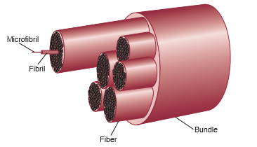

* Wide range of diversity.
* At least 28 types are present.
* Collagen synthesis occurs inside fibroblasts.

tropocollagen

microfibrils

fibrils

* Collagen fibrils – transverse striations (64 nm).
* Main type of collagen in pdl – Type 1 & 3 ( >70 % - type 1)
* Small amounts – type 5 & 6
* Traces – 4 & 7 are found.

**PRINCIPLE FIBERS:**

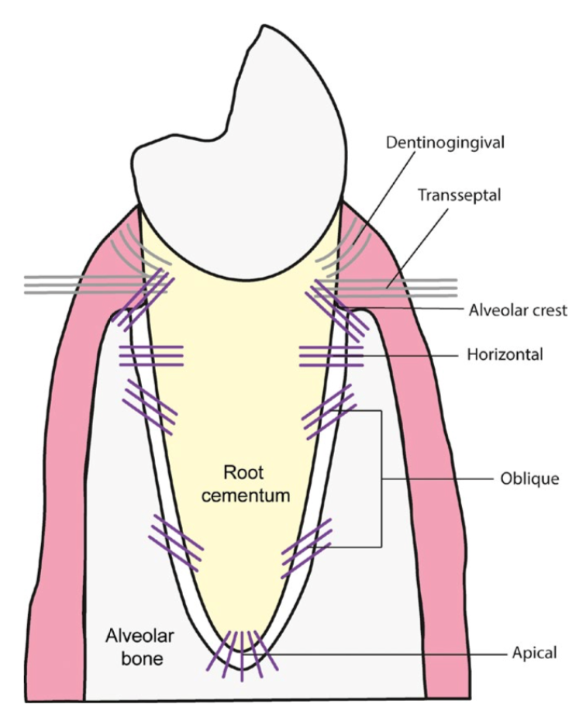

* TRANSSEPTAL GROUP:
  + Interproximally, over alveolar crest to adjacent teeth cementum .
  + Reconstructed even after destruction of alveolar bone.
* ALVEOLAR CREST GROUP:
  + Obliquely, from cementum beneath the JE to the alveolar crest.
  + Resist – tilting, intrusion, extrusion & rotational forces.
  + Incision – does not cause mobility.
* HORIZONTAL GROUP:
  + Run at right angles to the long axis of the tooth cementum to the alveolar bone.
  + Resist – horizontal & tipping forces.
* OBLIQUE GROUP:
  + Most numerous
  + Inserted into alveolar bone at a coronal position than their cementum attachment – obliquely.
  + Resist – vertical & intrusive forces.
* APICAL GROUP:
  + From cementum at root tip to fundus of bony socket.
  + Resist – luxation, tooth tipping,
  + protect blood & lymphatic vessel, nerves at root apex.
  + Not seen in an incompletely formed roots.
* INTERRADICULAR GROUP:
  + Inserted into cementum from crest of interradicular septum in multirooted teeth.
  + Resist – tipping, torquing & luxation.

ELASTIC FIBERS:

* PDL does not contain mature elastic fibers, two immature forms are found:
  1. Oxytalin
  2. Elaunin
* Oxytalin fibers :
  1. Run parallel to root surface & bend to attach to the cementum at cervical 3rd of the root.
  2. They are thought to regulate the vascular flow.

OTHER STRUCTURES:

BLOOD VESSELS:

* Pdl show abundant vascular supply, may be due higher or elevated metabolic requirments.

ARTERIAL SUPPLY:

* Inferior & superior alveolar arteries to mandible & maxilla respectively.
* It reaches the PDL through three sources:
  + Branches from apical vessels.
  + Branches from intra-alveolar vessels.
  + Branches from gingival vessels.
* Rich vascular plexus at apex & in cervical part of pdl
* Blood supply increases from incisors to molars.

VENOUS DRAINAGE:

* Veins accompany their arterial counterparts.
* Receive blood from capillaries & glomera
* Dense network – apex.

LYMPHATIC DRAINAGE:

* Lymph from periodontal tissues drain into lymph nodes of head & neck.
* Sub-mental – labial & lingual gingiva of mandibular incisors.
* Sub-mandibular – lingual gingiva of mandibular premolar & molar region, buccal gingiva of maxilla.
* Jugulo-digastric – third molars drain directly.
* Deep cervical – maxillary palatine gingiva.

NERVES:

* Functionally two types : sensory & autonomic .
* Sensory fibers – nociception & mechanoception with pain, pressure, touch & proprioceptive sensation.
* Autonomic fibers are associated with vessels.

CEMENTICLES:

* Calcified bodies seen in the pdl.
* Free or bound forms.

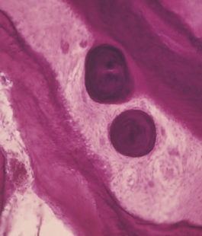

FUNCTIONS OF PDL:

PHYSICAL FUNCTIONS:

* Soft tissue casing to protect vessels & nerves.
* Transmission of occlusal forces to the bone.
* Attachment of the teeth to the bone.
* Maintenance of gingival tissue.
* Resistance to impact of occlusal forces.

RESISTANCE TO IMPACT OF OCCLUSAL FORCES ( SHOCK ABSORPTION):

* Three theories are used to explain:
  + Tensional theory
  + Viscoelastic theory
  + Thixotrophic gel theory

TENSION THEORY:

* Acc to this, principle fibers are major factors in supporting the teeth & transmitting forces to the bone.

Upon force application

fibers unfold & straighten

transmit force to alveolar bone

elastic deformation of bony socket

further force is transmitted to basal bone.

VISCO-ELASTIC SYSTEM THEORY:

Forces on tooth

Extracellular fluid of pdl into marrow spaces

The fiber bundles absorb slack & tighten

Blood vessel stenosis

Arterial Back pressure cause ballooning of the vessels

Passage of Blood ultra-filtrates into the tissues

Replenishing the tissue fluid

THIXOTROPHIC THEORY:

* Pdl has behaviour of thixotropic gel
* Property of becoming fluid when shaken or stirred & then becomes semisolid again
* Force application leads to : gel to fluid form.
* Removal of force causes : fluid to gel.

TRANSMISSION OF OCCLUSAL FORCES TO BONE:

* Principle fibers – suspension bridge or hammock.
* Axial forces tendency to displace root into bone.
* Oblique fibers alter major part of axial forces.
* horizontal or tipping forces two phases of tooth movements.
* 1st within confines of pdl
* 2nd displacement of facial & lingual bony plates.

FORMATIVE & REMODELLING:

* Cells of pdl formation & resorption of cementum & bone.
* Pdl constantly undergo remodelling, old cells & fibers are replaced by new once.
* Resident mesenchymal cells develop into osteoblasts & cementoblasts.

NUTRITIONAL FUNCTION:

* Pdl supplies nutrients to the cementum, bone & gingiva by blood vessels & also provides lymphatics.
* Its highly vascular, it provides hydrodynamic damping to applied forces.

SENSORY FUNCTION:

* Pdl shows abundant nerve supply for transmitting tactile, pressure & pain.
* Nerve bundles pass into pdl through apical foramen & divides into single un-myelinated fibers that loose the mylein sheet & ultimately end as follows:
* Free endings, tree like configuration & carry pain.
* Ruffini – like mechano-receptors, located in apical area
* Coiled meissner’s corpuscles – mechano-receptors in mid-root region
* Spindle like pressure & vibration endings, located at apex.

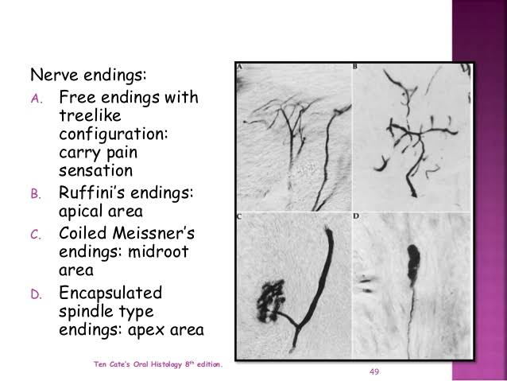

PERIODONTAL LIGAMENT HOMEOSTASIS:

* Pdl has capacity to maintain its width more or less overtime.
* Studies suggest that cell with in the pdl, both during development & regeneration, secrete molecules that regulate extent of mineralization & prevent ankylosis.
* Molecules that play role in maintaining un-mineralized pdl is : Msx2, Matrix Gla protein, TGF-β, Prostaglandins, balance between bone sialoprotein & osteopontin activity.

AGE CHANGES IN PDL:

* With age decreased number of fibroblasts, decreased organic matrix production, increased amount of elastic fibers, etc.
* Functional status of the tooth determines the width of the pdl, width of space is decreased if tooth is unopposed (hypo function) or will increase with excessive occlusal loading.
* In investigation of role of pdl in maintaining periodontal health & pathogenesis of periodontitis, one approach is to examine the mediators of bone homeostasis such as RANKL & osteoprotegerin.

Clinical considerations:

* For the practice of restorative dentistry, supporting tissues play an important role.
* Supporting tissues of the tooth long out of function are poorly adapted to carry the load when restored like bridge abutments, teeth opposing bridges or dentures and teeth used as anchorage for removable bridges.
* Acute trauma to PDL, accidental blows, or rapid mechanical separation may produce mechanical changes, such as fractures, resorption of cementum, tear of fiber bundles, haemorrhage and necrosis.
* The adjacent alveolar bone is resorbed, the pdl is widened and tooth becomes loose.
* When trauma is eliminated, repair usually takes place. Occlusal trauma is always restricted to the inta-alveolar tissues and does not cause changes of the gingiva such as recession or pocket formation or gingivitis.
* Orthodontic tooth movement depends on the resorption and formation of both bone and PDL. These can be stimulated by properly regulated pressure and tension.
* If the movement of the tooth is within physiological limits, the initial compression of PDL on pressure side is compensated for bone resorption, where as tension side bone apposition is seen.
* Application of large forces results in necrosis of PDL and alveolar bone on pressure side and movement of tooth will occur only after the necrotic bone has been resorbed by osteoclasts.

CONCLUSION:

* The commonest pathology related to pdl is chronic inflammatory periodontal disease.
* Toxins released from the bacteria in dental plaque and metabolites host defense mechanism destroy the pdl and adjacent bone. Further, progression of periodontal disease leads to tooth mobility and tooth loss.
* Repairing the existing destruction of pdl is quite challenging, involves limiting the disease process and regenerate host tissue.
* Various surgical techniques like guided tissue regeneration, are used to correct pdl destruction.
* More recently tissue engineering principles used with biological properties like gene therapy, use of biocompatible scaffolds (with growth factors) offer an alternative to existing therapies.
* Bioactive molecules like growth factors, cytokines, bone morphogenic proteins and certain enamel proteins, natural bone minerals have been used to induct formation of pdl cells and help in periodontal regeneration.
* A better understanding of cell and molecular biology of the developing and regenerating periodontium offers newer avenues.

**REFERENCES:**

* **Carranza’s clinical periodontology – 11th edition.**
* **Jan Lindhe, Niklaus P. Lang – 6th edition; clinical periodontology and implant dentistry.**
* **Orban’s oral histology and embryology – 13th edition.**
* **Dr. Dean. R, The Periodontal Ligament: Development, Anatomy and Function : OHMD- Vol. 16- No.6- December,2017.**
* **Jong T. De, Bakker A.D, Everts. V, Smit.T.H: Review Article: The intricate anatomy of the periodontal ligament and its development: J Periodont Res. 2017;1-10.**